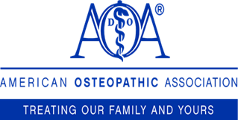

Certificate of Participation
The American Osteopathic Association certifies that

<name >
has participated in the <activity type> activity titled:
< name of conference/activity>
<location>
<City, State>

on <Date>
Total AMA PRA Category 1 Credits™ awarded is <credits>. Participation is equivalent to the total number of credits claimed.

This activity has been planned and implemented in accordance with the accreditation requirements and policies of the Accreditation Council for Continuing Medical Education (ACCME) through the joint providership of the American Osteopathic Association (AOA) and <name of joint provider>. The AOA is accredited by the ACCME to provide continuing medical education for physicians.

The AOA designates this <activity type> activity for a maximum of <credits> AMA PRA Category 1 Credits™. Physicians should claim only the credit commensurate with the extent of their participation in the activity

This live activity was co-sponsored by the:
Co-Sponsors logo
Co-Sponsors logo

__________________________
Signature of Program/Activity Chair & Printed Name

